Xinyu (David) Liu
Modern Instrumentation 327
Lab 7: Digital Basics, Counter and Timer

Introduction:

(formulas for charging and discharging times of 555 timer, page 207)

Part 1 Methods: Testing of LED’s

LED’s (light-emitting diodes) were used in this lab to indicate the on and off status of output in and input in the logic gates. To test that they were functional, they were connected to 5 V and connected in series with a 270 Ω resistor to prevent burnout.

Results:

When voltage was applied over each of the five LED’s tested, the light went on as expected. The p type semiconductor faced the +5 V while the n type faced the ground. Since the p type is made positive in comparison to the n type, there is no potential barrier between the two types and charge flows into the depletion region causing the current necessary for the LED to light up.

Part 2 Methods: Testing of quad-NAND chip

The quad-NAND gate in figure 1 has 14 pins, with pins 14 and 7 being a 5 V supply voltage (for TTL / transistor-transistor logic) and the rest being the input and outputs for four NAND logic gates.
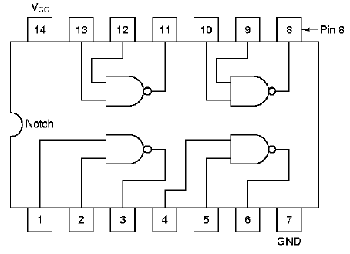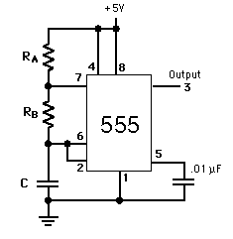
Figure 1: 74LS00 Quad NAND Figure 2: 555 Timer

To test that each NAND gate was working, each output was connected to the N type semiconductor of a LED. Since the chip cannot supply enough current to drive the LED, no light was interpreted as “on” or “hi” and a light was interpreted as “off” or “lo”. Using several combinations of NAND gates, NOT, AND, and OR gates were built and tested.

Results: The results of the tests are given in the following logic tables.

NOT Gate 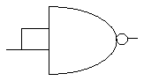
Input | LED status | Output
Hi (1) | On | Lo (0)
Lo (0) | Off | Hi (1)

AND Gate 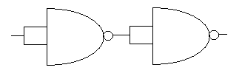
Input 1 | Input 2 | LED status | Output
Hi (1) | Hi (1) | Off | Hi (1)
Hi (1) | Lo (0) | On | Lo (0)
Lo (0) | Hi (1) | On | Lo (0)
Lo (0) | Lo (0) | On | Lo (0)

OR Gate 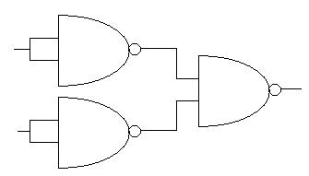
Input 1 | Input 2 | LED status | Output
Hi (1) | Hi (1) | Off | Hi (1)
Hi (1) | Lo (0) | Off | Hi (1)
Lo (0) | Hi (1) | On | Lo (0)
Lo (0) | Lo (0) | On | Lo (0)

Because these logic tables agreed perfectly with the reference logic tables, we know that the NAND gates used in this test worked perfectly. The LED statuses were counterintuitive because OFF status corresponded to a Hi output and ON status corresponded to a Lo output voltage. However even though the results were flipped they were consistent.

Part 3 Methods: 555 Timer

The external configuration shown in Figure 2 of a 555 integrated circuit causes it to act as an astable multivibrator. The 555 triggers itself to output a continual wave because C alternates between 2/3 V_{cc} and 1/3 V_{cc}.

With C = 1000 pF, R_{a} = 330 kΩ_{, and Rb} = 470 kΩ, V_{output} was measured using the oscilloscope and the charging and discharging times compared to the formulas (see Introduction). The wave on pin 2 was also measured. Last, C was changed to 1 μF and a LED was attached to the output to indicate the oscillations of V_{output}.

(The astable vibrator as no stable states which is why it oscillates back and forth)

Part 4 Methods: Divide by Two Circuit (half 7474 chip)

A D flip-flop (half of a TTL 7474 circuit) was used to build a divide by two circuit for the 555 timer attached to it (see figure 3). A LED was attached to the output of the flip flop to measure the frequency of oscillation. The circuit is so named because it supposedly “divides” the frequency of a lone 555 timer by 2 (see results for explanation of how). The clear and preset inputs were connected to V_{cc}, which was a 5 V supply for the each 7474 IC.
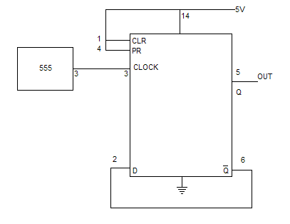
Figure 3: Divide by two timer

Results:

After connecting the divide by two circuit, the V_{out} was observed to oscillate exactly half as fast as the on and off cycles of the 555 timer. The LED attached to V_{out} indicated this by turning on and off. The data flip flop “latches” or freezes the state of the line at the instant that the clock input changes from off to on.

In figure 4, when clock input changes from lo to hi, Q output changes also changes from low to hi as indicated by the dotted line. While clock returns to lo, Q remains hi until the next time that clock changes from lo to high, as indicated by the next dotted line. This shows that a single D flip flop doubles the period of the output pulse from a 555 timer.

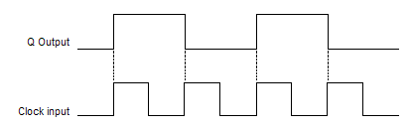
Figure 4: measured input and output pulses of D flip-flop

The clear and preset pins affected the state of the flip-flop independently of the clock and data line. Both CLR and PR pins were connected to pin 14 (V_{cc}) at 5 V and remained that way for the oscillation.

Part 5 Methods: Divide by 16 dual 7474 configuration (Binary counter)

A “divide by 16” configuration that acts as a binary counter was built by coupling the Q bar output to the next clock input (see figure 4). This was done with the 4 data flip-flops of two 7474 IC’s. A LED was attached between each of the four Q bar – clock input connections to measure the frequency.

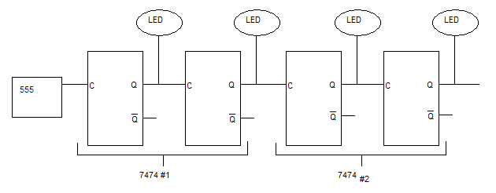
Figure 4: Binary counter (see figure 3 for details of each individual D flip-flop

Results:

With only half a 7474 chip, the period of oscillation of the 555 timer was doubled and frequency was halved. However, this time with four D flip-flops and each Q output being fed back into the clock inputs of the next D flip flop in line, each successive output had a frequency half as much as the previous one.

As expected, the LED closest to the 555 timer had a frequency half as much as that of the 555 timer. The second LED had a quarter of the frequency as that of the timer, the third an eight, and the last 1/16. This acted as a binary counter because each LED represented a digit of a four bit number.

Initially all four LED’s were ON, meaning the outputs were lo (because the output is attached to the n-type semiconductor on the diode) and the number could be read as 0000. Next, LED1 turned off, representing 0001. Then, LED1 turned back on and LED2 turned off, representing 0010. This repeated 12 more times until all four LEDs were turned off, which was equivalent to 1111 or 15 in decimal.

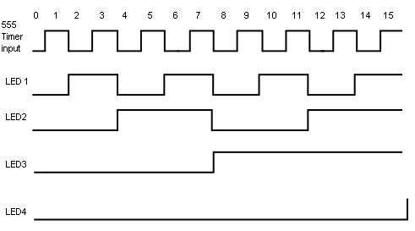
Figure 6: Oscillation chart for four bit binary counter

Part 6 Methods: 7448 decimal counter disply

The binary counter had four “digits” each with 1 or 0 status. It counted from 0000 to 1111. A 7448 chip was used to convert these binary numbers to decimal to make the 555 timer status easier to read.

It does not take as input the lines in figure 4 where the four LED’s were connected (the Q outputs), otherwise the display would have shown “dark” numbers on a “light” background instead of the other way around because a hi output voltage would have to correspond to the LED being on and a lo output voltage would have to correspond to the LED being off. Instead, the four BCD pins of the 7474 chip, bcd4 through bcd1 take as input the Q bar pins from left to right in figure 4. A 270 Ω resistor was placed between the 5 V and ground pins of the display to prevent burnout. The seven lines lettered a through g were the LED segments used to display the decimal numbers.

Results:

As expected, the binary counter in the previous section outputted the appropriate Q bar voltages to count up from 0 to 9. Since there were only 7 LEDs that did the counting, i.e. the other digit of the 7448 chip was not used, the display did not show 10 through 15 correctly. As shown in figure 7, several non-numerical symbols were displayed when the binary counter counted from 1010 to 1111. After 1111, however the counter reset to 0000 as expected and the 7448 display showed “0”.
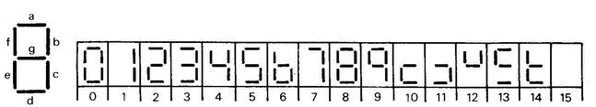
Figure 7: Progression of numbers displayed on 7448 BCD decoder

Conclusion:

